Nama : Tri Joyo Priambodo

NIM : 18090099

Kelas : 5B

**PRAKTIKUM 5**

1. Source Code

Autoload.php => application / config.php

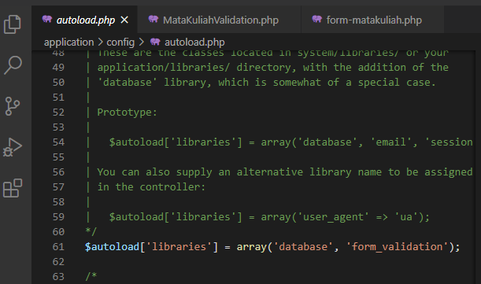

MatakuliahValidation.php => application / controller

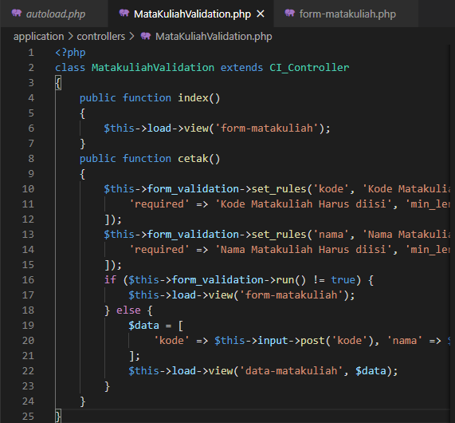

form-matakuliah.php => application / views

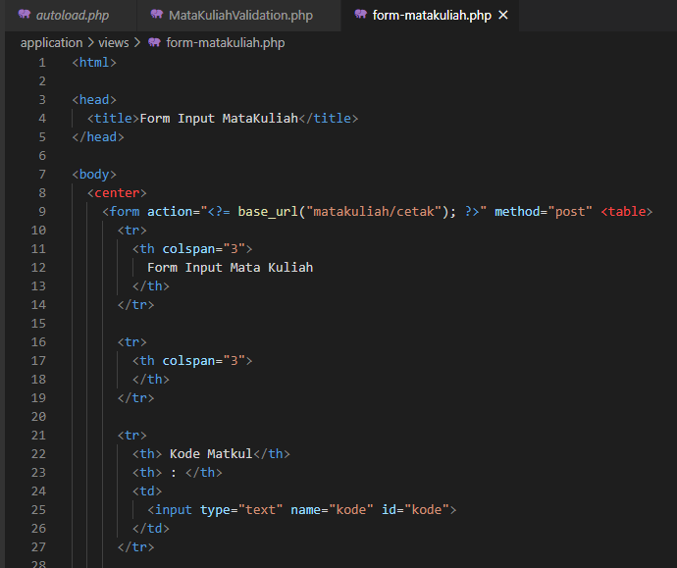

1. URL

<http://localhost/pustaka_joyo/index.php/MatakuliahValidation>

1. Capture Hasil

